AFRICAN UNION PEACE SUPPORT OPERATIONS DIVISION TEAM CONDUCTS PRE-DEPLOYMENT VERIFICATION ON LEOBATT 2
The First Sierra Leone Battalion (LEOBATT 1), comprising 850 officers and men, was deployed with the African Union Mission in Somalia (AMISOM) since April 2013 in order to bring peace and stability to the people of Somalia. The battalion has excelled itself and it is held to high esteem for its professionalism and operational effectiveness since its deployment. Because of this, the Sierra Leone Contingent was recently assigned to a new Sector (Sector KISMAYO) and no longer operating under the Kenyan Sector. After serving for over one year, LEOBATT 1 is now due for rotation with the Second Sierra Leone Battalion (LEOBATT 2).

As a requirement for troops deploying on peacekeeping missions, a pre-deployment assessment is conducted by representatives of the AU or UN, as the case may be, in order to ascertain the level of preparedness of the contingent before they are cleared to deploy. Thus, a team from the African Union Peace Support Operations Division (PSOD) headed by Colonel FIDZA DLUDLU arrived on Sunday 29th June with the sole aim of conducting pre-deployment assessment on LEOBATT 2 to ascertain its level of preparedness to relieve LEOBATT 1, especially in terms of soldiers personal kits, equipment and other essentials required for troops’ survival in the mission area.
On Day 1 (30th June 2014) of the visit, the team paid courtesy calls on the Hon Minister of Defence, Major (Rtd) Alfred Palo Conteh and the Chief of Defence Staff, Major General Samuel Omar Williams. This was followed by a presentation by the Director of Peace Keeping Operations at the MoD, Lieutenant Colonel AK Fefegula.
On Day 2 (1st July 2014), the team visited the Peace Mission Training Centre (PMTC) at Hastings where the assessment on LEOBATT 2 was conducted. The team was first given a joint briefing by the RSLAF Training Group Commander (Colonel SET Marah), the Commanding Officer of PMTC (Wing Commander Hassan Coomber) and the Commanding Officer of LEOBATT 2 (Lieutenant Colonel George Mamoud Bangura). The brief covered the training standards achieved by LEOBATT 2 and its state of readiness for deployment. The team was then taken on a conducted tour of the training exercise area where they witnessed snap demonstrations on Static Defence, Sniper Hide Operations and Base Camp Security. At each stand, the commander gave a brief narration of the operational activity being demonstrated. The visiting team was highly impressed with the beauty of our training area and the professional manner in which the demonstrations were conducted.
The verification exercise on documentation commenced on the third day (2nd July) and ended on Thursday 3rd July 2014. The whole assessment visit concluded on this same day with a back brief by the visiting team to the senior management of the Ministry of Defence before leaving the shores of Sierra Leone on Friday 4th July. The overall assessment of the verification exercise was highly positive with a lot of commendations from the team. The deployment of LEOBATT 2 is expected to take place within the next 2 weeks.
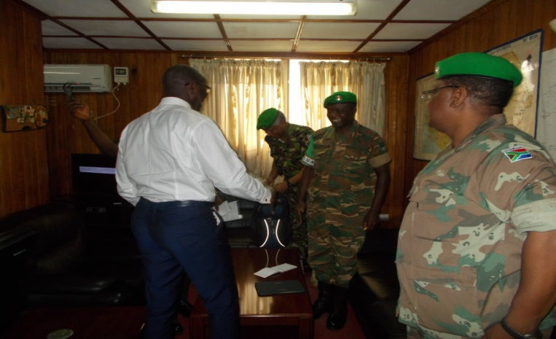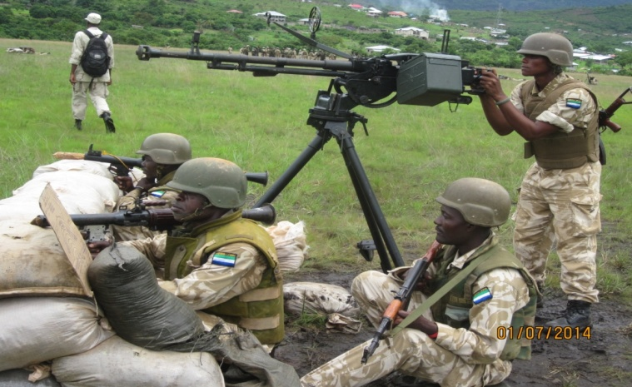
Courtesy Call on Hon MD by Team An Anti-Aircraft Gun Team Demonstration
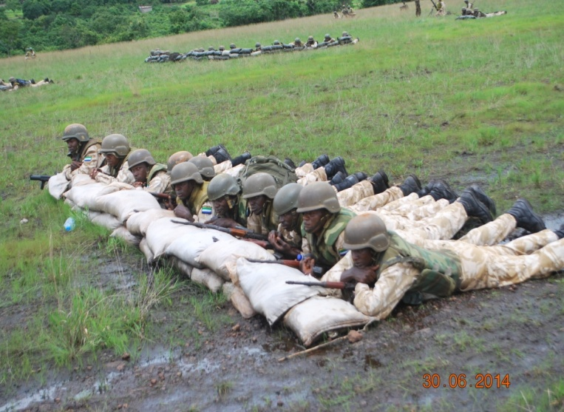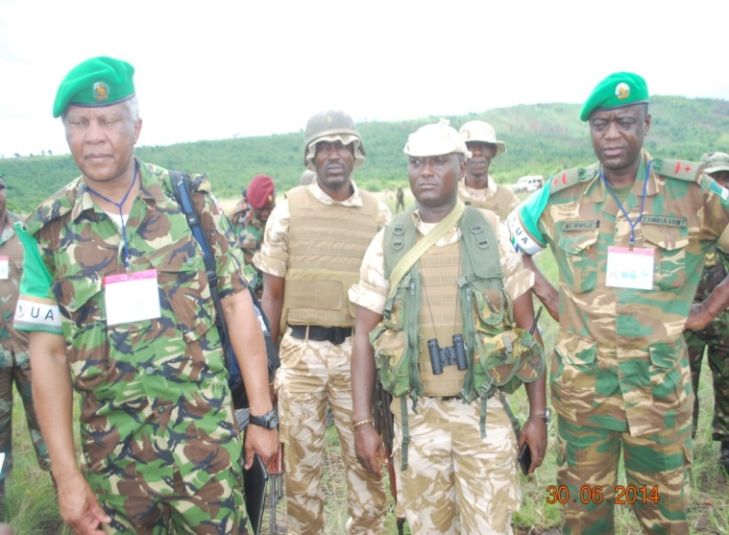
A Section in Position Team Watching a Demonstration

